

National Textile University

**Department of Computer Science**

**Subject**

**os**

**Submitted to:**

Sir nasir

**Submitted by:**

Hadi muhammad

**Registration Number**

23-NTU-CS-1160

**Lab No.**

05

**Semester**

**5th**

3. C Programs with Threads

Program 1: Creating a Simple Thread

Program 2: Passing Arguments to Threads

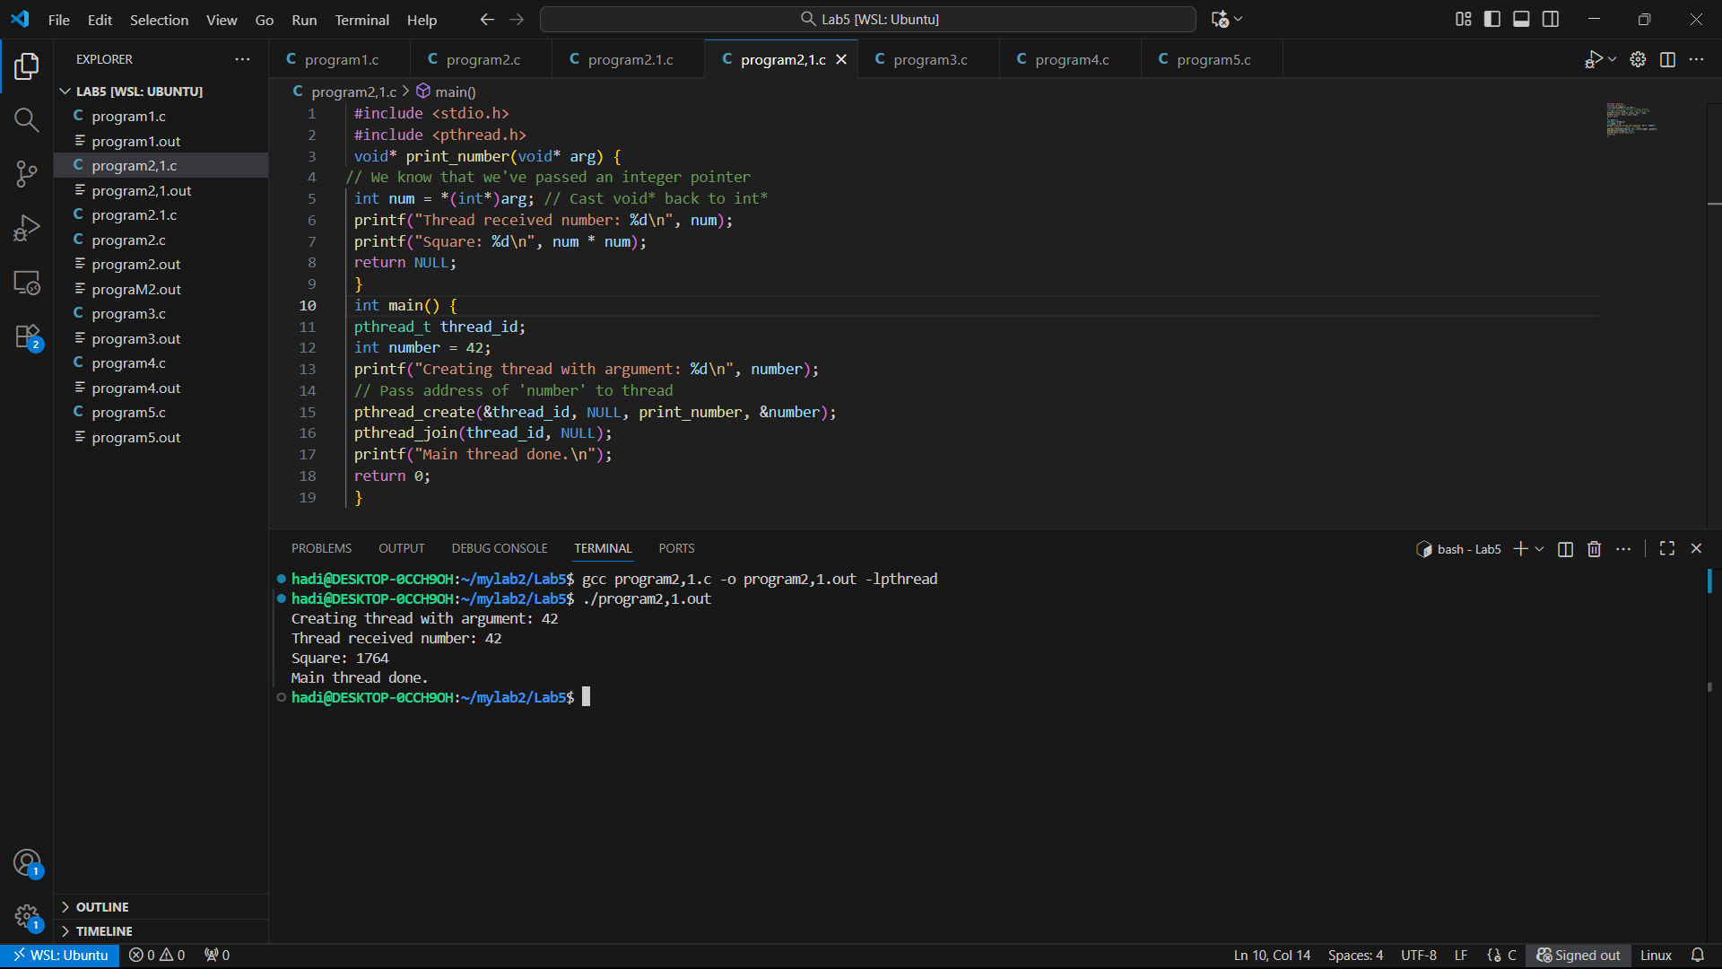

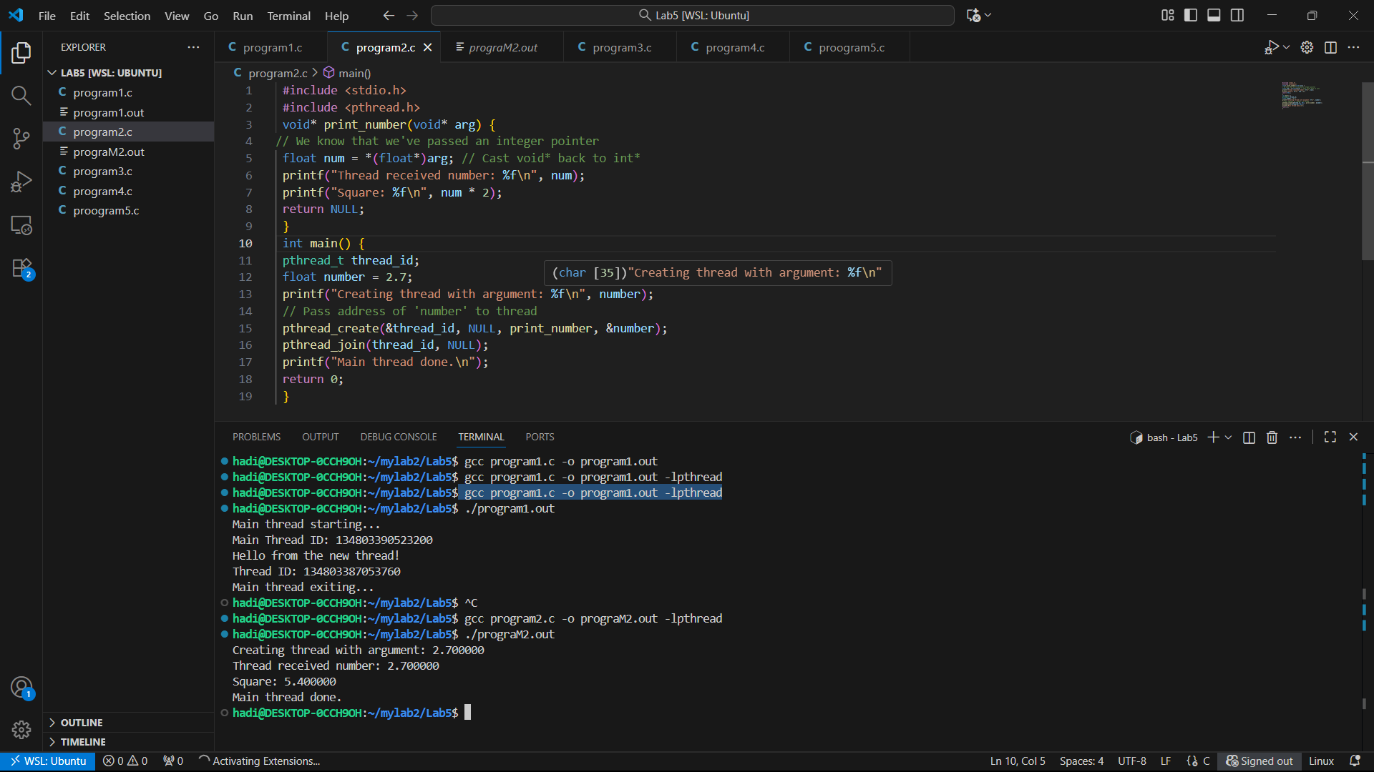

Program 3: Passing Multiple Data

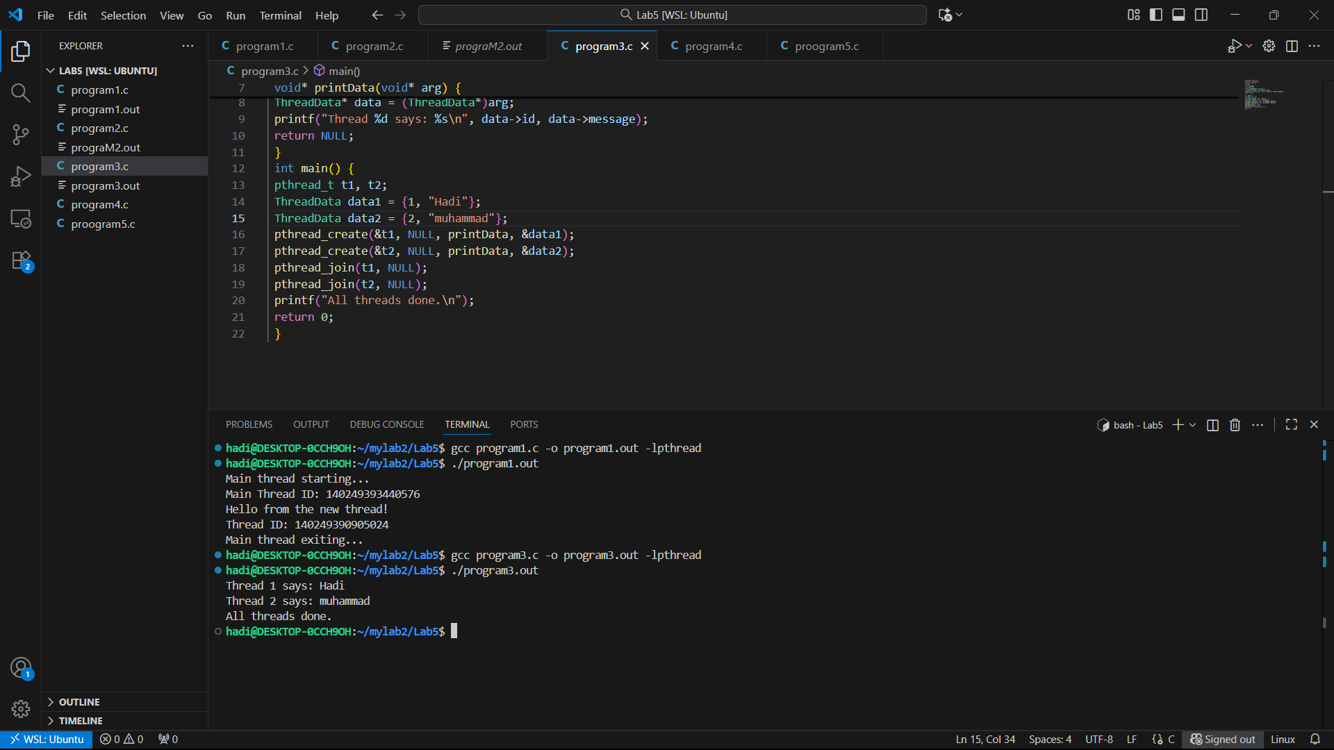

Program 4: Thread Return Values

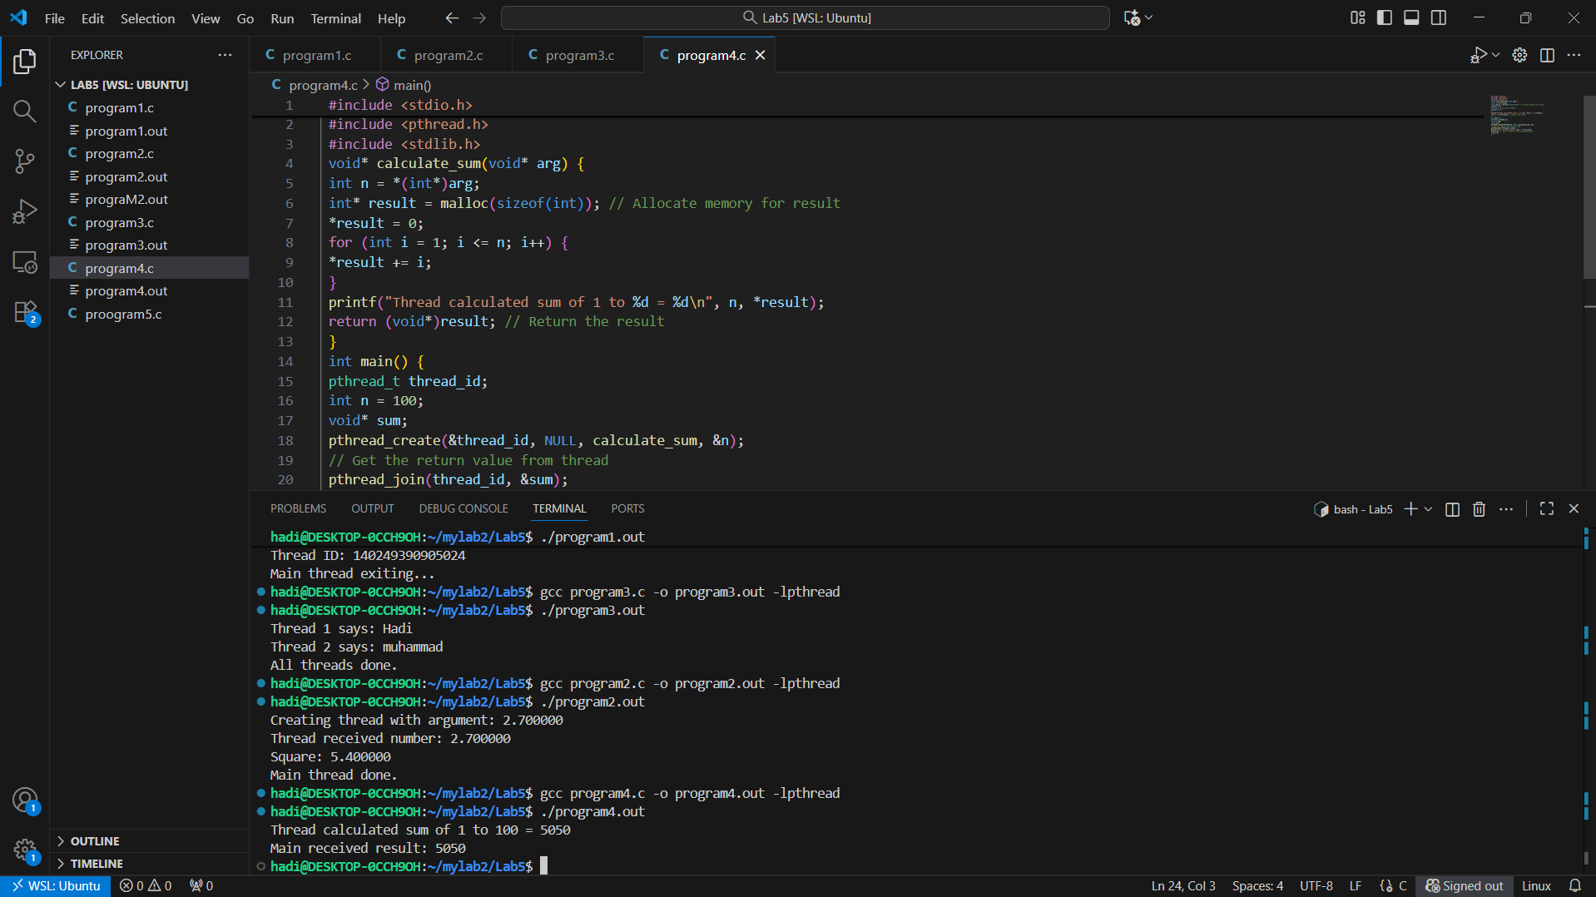

Program 1: Creating and Running Multiple Threads